March 8, 2011

The 112th Congress of the United States
House of Representatives
Washington, DC 20515

Re: Endorsement of Equal Rights Amendment Resolution

To the 112th Congress of the United States:

As the founder of Katrina’s Dream I follow in the steps of my late mother-in-law, the Reverend Katrina Martha Swanson. She dreamed of an America that would have welcomed her and all women with Equal Rights. In conversations with her during her last sixteen months, she knew that the country she loved would one day treat women equally. It has been my privilege to talk with people across America – from Representatives and Senators in our nation’s capital to groups meeting in bars and coffee shops from Maine to California.

I can speak for a large number of Americans, women and men, who are waiting for our Congress to make Equal Rights a part of the United States Constitution.

It is over 150 years since brave Americans gathered in Seneca Falls, New York, to demand an equality that was denied women then and shamefully is still denied today. Their unfulfilled words are engraved there on a marble wall:

“We hold these truths to be self-evident: that all men and women are created equal; that they are endowed by their Creator with certain inalienable rights; that among these are life, liberty, and the pursuit of happiness; that to secure these rights governments are instituted, deriving their just powers from the consent of the governed.”

The ERA passed in Congress in 1972, and was sent to the states for ratification. Unfortunately, by the time the allotted deadline had passed in 1982, the ERA was just three states shy of the thirty-eight ratifications necessary for inclusion in the Constitution. I believe the states deserve another chance to pass this historic amendment.

I write representing the dead and the living – men and women who dream of a justice and equality America has never known.

As oppressed women and men in foreign lands are demanding full human rights in the streets of their nations, will our Congress deny equality to fifty-one percent of our citizens? And suffering with them we see children who share the second rate status of their mothers.

It is my privilege, respectfully and at the top of our voices, to demand that you grant full justice for women by passing the Equal Rights Amendment.

Sincerely,
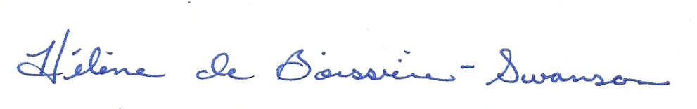
Hélène de Boissière-Swanson
Founder, Katrina’s Dream

