WALK the TALK
A Quest for Equality

Written by Hélène de Boissière Swanson

WALK the TALK

A Quest for Equality

Written By

Hélène de Boissière Swanson

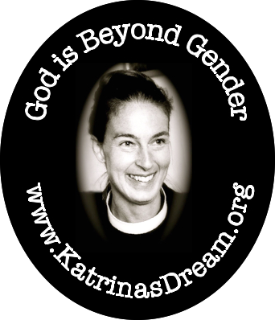

A Katrina’s Dream Publication

First published in the United States of America 2015

Katrina’s Dream, Inc. P.O. Box 32003, Washington D.C. 2007

Copyright © Katrina’s Dream 2015

All rights reserved. No part of this book may be reproduced or
transmitted in any form or by any means, electronic or mechanical,
including photocopying, recording or
by an information storage and retrieval system,
without permission in writing from the publisher.

Katrina’s Dream, Inc. does not necessarily endorse
the individual views contained in its publications.

The author and publisher have made every effort to ensure
that the external website and email addresses
included in this book are correct and up to date
at the time of going to press.
The author and publisher are not responsible
for the content, quality or continuing accessibility of the sites.

To my beloved, husband William Gaines Swanson,

whom came into my life showing me how to walk the path of believer

and my two sons Robert R. deBoissiere-Rudl and Harold M. deBoissiere-Rudl

whose steadfast belief and support made this endeavor a dream to reality
,
whom will inherit the responsibility of care for this planet.
I

White Ants

The Lord God said: I myself will dream a dream within you,
Good dreaming comes from me, you know.
My dreams seem impossible,
not too practical nor for the cautious man or woman;
a little risky sometimes,
a trifle brash perhaps.

Excepted from God’s Dream by Guy Peguy (1874-1914)

Sounds of a slow steady train pulling into the station, a sluggish chugging of one carrying a heavy load, stirred me from a sound sleep. As anticipated, it eventually came to a stop. Moments later it pulled away. Half awake, half asleep, I could hear Rev. Magdaliya Kamble and my beloved husband William talking in the kitchen. I listened for a short while and although unable to make out their words, I could tell from the hushed tone of their voices that it was a private conversation. Completely trusting William, I felt at ease drifting effortlessly back to sleep. Predictably, moments later a second train in the distance could be heard rapidly approaching. The second train did not have the sound of one carrying a heavy load and traveling a bit faster arrived quickly coming to an abrupt screeching stop. Shortly thereafter, just like the previous train could be heard pulling away.
Over the past several weeks while visiting Magda and the Kamble family during the 2012 Christ Mass Season at Garrison Church. I had become accustomed to the sounds of these two trains. William and I were there on a goodwill mission. William was to preach the Watch Night Service on December 24th and me the following Christ Mass Day Service. The trains like clockwork roared in each morning shaking the ground as the sun rose to welcoming the day. The subsequent azhan from a nearby mosque, calling believers to worship Allah also greeted the day. Since our arrival at Camp Devlali, an Indian Army Cantonment Board Military Base, in the Nasik Region of Maharashtra things had been most remarkable. The cacophony that morning was oddly reassuring and feelings of being blest swept over me, just as they had the first day that I participated in spirit with my brothers and sisters of the Muslim
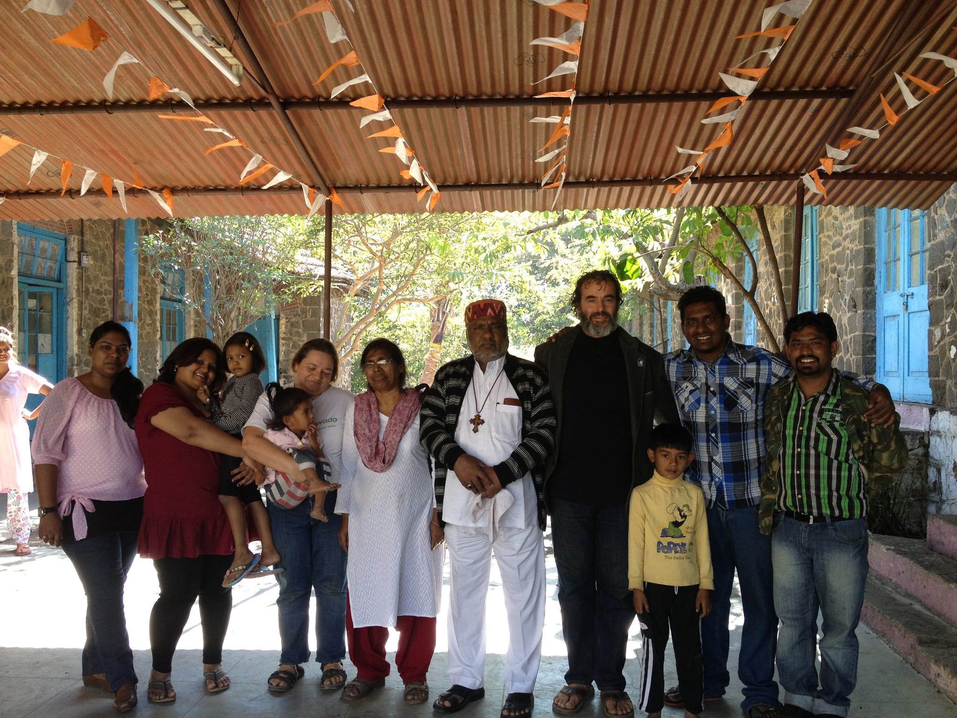Fig. 1.1 From left to right Preeti, Garima and Gia, Helene and Diana, Rev. Magda, Bishop Pradip, William, Little William, Anand, and Siyon.
faith in the worship of their God through the two-man stone walls of the old Garrison Church. What a
glorious moment it is when no matter the faith, culture, or language, which one feels when connecting to the God of ones’ understanding.
The next sounds that stirred me from my slumber were the noises of the morning revelry. A French horn demanded in melodious form for all to hurry up and get in line and stand at attention, then a commanding officer barked out orders in Hindi and the routine practice of soldiers firing their guns. Camp Devlali was home to the prestigious Indian Army School of Artillery. Like the Islamic call to worship, while I could not see what was taking place nor understand the words, I imagined the unfolding events.
Drifting in and out of sleep I listened to the unintelligible intercourse taking place in the kitchen with the backdrop of the daily morning routines of this small military base situated on the banks of the river Darna, and in the Sahyadri Mountain Ranges of Igatpuri and Trymbak, near the high mountain of Trirashmi. Mt. Trirashmi being the place of the ancient Buddhist Pandevleni Caves, where local kings had carved idols of Buddha and Bodhisattva placed in the caves during 4th century BC through the 12th century AD, had greatly influenced the region lending a distinct air of calm and peace. The sounds I came to expect each morning, sounds of the trains, sounds of Morning Prayer, and sounds of soldiers preparing for their day brought a sense of tranquility.
An indeterminable amount of time had past, I could still hear Magda and William conversing in the kitchen. Deciding that I should arise and join them, I gently pushed back the mosquito netting and swung my feet out of bed onto the cool cement flooring and pitter pattered off to the kitchen. Magda was pouring William a cup of tea.
Looking up she said, “Ah Sister Helen, you have come to join us. Yes? Let me get you a cup.”
Groggily I nodded, pulling up an aluminum dinette chair along side William, pecking him gently with a kiss on the cheek. I promptly sat down next to him at the small metal kitchen table. Along with the cup of tea came toast, a cut-up banana and Magda saying, “Eat. Eat.”
I greedily gulped down my tea, looking at Magda for more. Smiling she went over to the stovetop and came back with a pot of the delicious brew of chai tea, milk, and sugar melted in sweetening the tea to perfection. The tea consisted of the spices ashwagandha, mulethi, tulsi, cardamon, and ginger. She refreshed both of our cups. Over the weeks staying at her church Magda fussed over us when I had become quite feverish preparing special curried dishes to restore my health.
Again, I gulped down my tea. A fever had left me in a wretched condition. Weaken, achy bones and still rather dehydrated, I used this as an excuse to get more tea at every opportunity. Magda took pleasure in spoiling me in this fashion. When she delivered my third cup, making note that I had consumed my banana and toast she offered a bowl of rice, which I heartily agreed to by nodding ‘yes’. Upon returning with a healthy portion of plain white rice, Magda sat back down to enjoy a cup of hot tea. At which point a burning question, one that had been daunting me for several days, begging to be asked popped into mind.
“So Magda tell me, why did you invite us? Of all the people you know, why us?” I blurted.
She replied, “The white ants decided.”
“Excuse me? Magda did you say white ants?” I queried.
“Haan. Haan. White ants.”
Wincing my eyes again I asked, “I don’t understand. Are you saying ants like in crawling insects? Bugs?”
Again, Magda said ”Haan. Haan. White ants. Sister Helen, Brother William, come I will show you.”
She got up from the dinette table extending her arm, crooking her index finger motioning us to follow. William looked at me tilting his head left ever so slightly indicating that we should comply and see exactly what Magda meant by ‘the white ants decided’. Scurrying ahead Magda went through the parsonage, which was a series of converted connecting barracks, room by room. First into our bedroom, then into a narrow passage way, then into the larger oversized parlor which also double as her office, over to her desk and pulled out the keys to the church. By which point we had now caught up and were in step with her.
We entered into the courtyard where just a few nights before we had celebrated Christ Mass Day into the wee hours of the morning with the Kambles, an intimate number of close friends, and a few members from the smallish congregation. The vibrant decorations and glittering rainbow colored tinsel were still hanging here, there, and everywhere, giving the grounds a festive feel. I looked at the ashed filled fire-pit where Anand, Magda’s son, had built a toasty fire and played a wide variety of Indian traditional songs and pop music. As Magda fumbled with the oversized ring of keys to unlock the gigantic mahogany wooden doors, I fondly recalled how he and his younger sister Preeti had urged William and I to dance remarking on how much in love we must be to dance so romantically. The favorite song of the evening, Gangnum Style by Korean rapper Psy, which swept the world with its catchy beat and lyrics, was played over and over again throughout the night. It was the closest thing William and I had had to a vacation in years.
Magda walked deftly down the center aisle of mahogany pews bearing left to a room in the side of the altar. She went into the sacristy. Opening up a dark brown wood armoire, pushing aside several vestments and stoles that priest typically wear to celebrate mass during the various liturgical seasons, moving over the chalice and paten used in the sacrament of Holy Communion. She produced a large antique rectangular shaped rusty forest green metal lock box. She carefully took the lock box out and set it down on the oversized wooden table, which crowded the room, pushing the church registry book over to her right. William and I watched with great anticipation, our curiosity peaking as children do when gazing at Christ Mass presents under the tree. We glanced at each other with incredulity as she then proceeded in going through the numerous keys on her ring, stopping at an old skeleton style key. Within seconds, the box was unlocked. Astonished we stared at the contents: a Katrina’s Dream lapel pin and a single book - the Holy Bible.
Magda declared, “See white ants”.
Exploratively William came over to Magda. Standing beside her he took the Bible out and placed it in front of the metal lock box. Gently leafing through the book, he discovered that most of the pages were gone, decimated by the gnawing of hungry ants. These ‘white ants’ had practically eaten the entire book, excepting for the Book of Genesis. There was practically nothing left of the Old Testament, nothing to speak of existed of the Gospels of Matthew, Mark, Luke, and very little of John from the New Testament. As he continued to turn what little was left of the remaining pages one by one, the holes created by these ravenous ants got smaller and smaller, disappearing completely at the Apocrypha. It became obvious that ‘the white ants’ had made a meal of the Holy Bible, literally consuming the Word of God.
“How bizarre.” I thought.
Whispering in awe, “What does this Bible and white ants have to do with why we are here? I don’t get it”. Dumbfounded I looked at William shaking my head from side to side. He too looked quizzical.
“Brother William see here your mother Katrina” Magda said, pointing to the oval shaped lapel pin lying inside the metal box. The pins bore an image of William’s mother, the Rev. Katrina Martha Van Alstyne Welles Swanson, crafted of a clear glossy epoxy protective finish covering the graphics, which were firmly fixed on a faux gold finish metal backing with a jewelry clutch. The graphic, a vignette of a black and white photograph of Katrina, was on a black background and the simple statement crowning her read ‘God is Beyond Gender’. Also in a circular fashion framing the bottom of her picture was the address of our website ‘www.katrinasdream.org’. The lettering was a white bolded Arial font. William had thought up the message and I choose the picture. We had designed the pins for our organization to give away at the 2008 Lambeth Conference. The Lambeth Conferences are the decennial assemblies of the bishops of the Anglican Communion convened by the Archbishop of Canterbury. The first such conference took place in 1867.
William was quite artistic and a savvy businessman too. Upon graduating from Boston University with a B.A. in Philosophy, he moved to Washington, D.C. After a short stint at the law firm of Swindler & Berlin, he decided against becoming a lawyer. It would have been simple for him to settle into an ‘easy life’. However, he came to the realization that for him a Bachelors of Arts in Philosophy from Boston University was just that, a degree. Choosing instead to internalize involvement in international affairs, which required living abroad. Inspired by the writer Ernest Hemingway he left for Barcelona to write a book for he also fancied himself a writer. Being a competition level swimmer in his high school days and during his college days a sailing instructor on Jamaica Pond and the Charles River in Boston. William was an extreme sports athlete and enthusiast he especially enjoyed the Olympics and Special Olympic Games. It was his plan to follow the Olympics and pick up work where work was to be found. At first, he struggled getting by and wound up washing the windows of automobiles at the corner of busy intersections. The Guards of Seville were not especially happy with him when he crafted a makeshift boat out of one-gallon plastic containers to sail on the Mediterranean Sea. Eventually he made friends and was directed to a construction site where he found work as a Rope Access Technician and ran a crew putting up the Hotel Olympia. The hotel was a joint venture of the Travelstead Corporation and the Shimisu Corporation, was being built in preparations of the ’92 Barcelona Summer Games. Popular with the other high-rise workers he earned the reputation of being a daredevil delivering lunch on his bicycle on the 34th floor scaffolding of the 42-story skyscraper. In Norway, he was the agent for Uganda’s Olympic ski jumper Dunstan Odeke and worked closely with his coach Geir Hammer. A car accident smashed the dreams of the Olympic hopeful and Dunstan was left unable to compete in the ’94 Lillehammer Winter Games. Affairs of the heart also played a role in Williams’ plans and he traveled to Tromsø, a city that bordered Russia. While there he sold pin badges, trinkets, and other Olympic memorabilia on the streets, showering at the university and sleeping on reindeer skins during the dead of winter. It was during these tough times that he discovered how to earn a living as a street vendor. While it was not a great fortune, he had more than sufficient funds to get to the next host city and start all over.
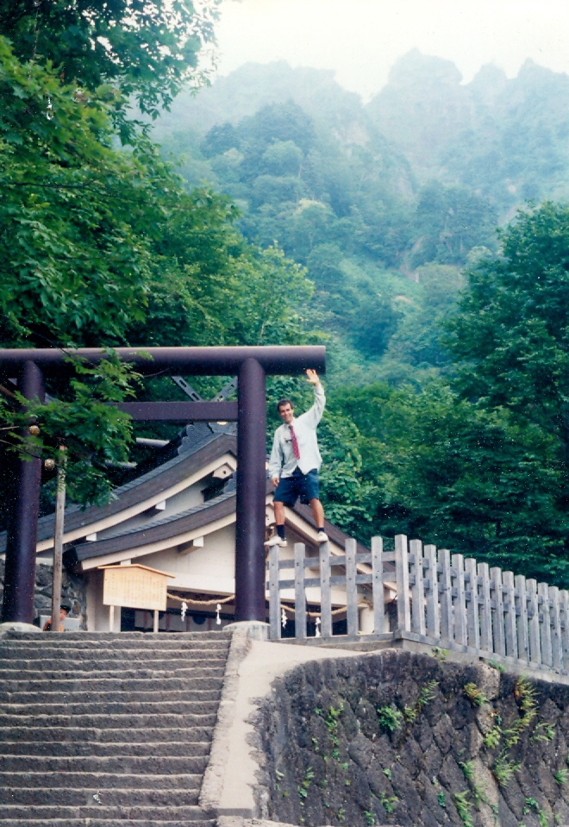Fig. 1.2 William hiking to the top of Mt. Fuji in 1998. Photo Credit: George Swanson
William had a knack for creatively identifying niches. He had a plan of action and the formula worked well. Utilizing his unique gifts and talents he would aid communities in their morphing into Meccas for the globally conscious, capitalistic entrepreneurs, and athletic enthusiasts. He would go months in advance to Olympic host cities identifying businesses providing them consulting services as to how best prepare for the upcoming games. In his spare time, he would scout the site of the games, determining where best to place pin badge traders having identifying the most foot trafficked locations. He made a small fortune in the ’96 Atlanta Summer Games where George, Katrina, and his brother Olof joined him in selling pin badges. By the time of the ‘98 Nagano Games in Japan, he had built a strong network in the Olympic family in the niche market of pin badges. While in Nagano, he worked for the Applegrimm Corporation training restaurant employees in customer service. Like Katrina, he had a fascination for foreign languages and so at Shinshu University as an English tutor and language learner he published a paper , which became the basis of Applegrimm’s employee customer service manual, co-authored with his brother Olof who caught up with him in Japan. Soon William was managing medium size groups of pin badge traders. Confidently he headed off to Australia but he lost his shirt when he tried to replicate this in Sydney. Desirous of working out a real estate deal for the ‘08 Beijing Olympics, William set out to spend more time in Japan, Taiwan, Indonesia and or course China. Work in the Olympic games community came to an abrupt end with the catastrophic event of September 11, 2001. The jihad terrorist attacks on the World Trade Center in New York City brought him home to the United States. In addition, this is how William traveled the world for the better part of 20 years.
Magda continued, “Me and Bishop went to England to Lambeth Conference. I met many people. All sorts of people, I did meet. They were from all over the world, Sister Helen. They would push their business cards into my hands. They did this. They pushed them into my hands. I met people from the United Nations and other good organizations, many important people who do good work. I was honored to meet these people. They would say to me ‘if I can ever help let me know’. I saved all these cards and papers I got from the conference. Brother William, I put all these things here in this box for safe keeping right next to the Holy Bible. So, they would be safe from problem people.”
Then Magda explained that she was a Bible Study Facilitator at the 2008 Lambeth Conference and that her husband Rt. Rev. Pradip L. Kamble, Bishop of the Diocese of Nasik, Church of North India, was one of the organizers. William shared that his great-great-grandfather, Bishop Edward Randolph Welles I, had helped to organize the Chicago-Lambeth Quadrilateral in 1886.
I thought back to our visit to England in 2008 to attend the Lambeth Conference. It was the first time it was held in Canterbury. Previously having being held at Lambeth Palace in London, the move to a new location was significant. Having learnt of the conference, I had a discussion with William about the necessity of going. I reasoned that if I was to fulfill his mother Katrina’s request, that I utilize my legal skills acquired while working for the famous international lawyer Melvin M. Belli, Sr., to pass the Equal Rights Amendment into the U.S. Constitution. Stating that it would not only benefit me, that it would also benefit our fledgling organization as it grew. It would be important for Katrina’s Dream to establish a presence in the Anglican Communion as a social justice organization. Knowing that a small stone tossed in a lake caused ripples and the ripples were felt on distance shores. I envisioned Katrina’s Dream as that small stone.

About the Author

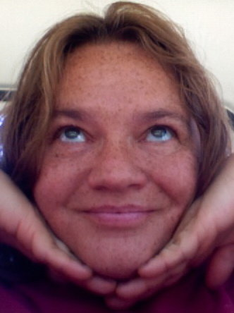
Hélène de Boissière Swanson, the author is a social justice activist from the United States. She is also the Founder and Executive Director of Katrina’s Dream (www.katrinasdream.org). She just completed a 10,000-kilometer pilgrimage across the United States for Women’s Rights. Helene is currently visiting the State of Maharashtra as guest of Bishop Pradip L. Kamble, Bishop of Nasik, Church of North India and his wife the Rev. Magdaliya Kamble of Garrison Church, Camp Devlali. While here she is working on her upcoming book Walk the Talk: A Quest for Equality.

Joseph L. Green, Jr., The Power of the Original Church, Turning The World Upside Down, (Shippenberg, PA, Destiny Image Publishers, Inc. 2011)
Eugène N. Marais, The Soul Of The White Ant (Great Brittan, Penguin Books Ltd, 1973)
E. Olof Swanson and William G. Swanson, Organic Learning: Applied to Language, (Nagano, Shinshu University 1998)
"Lambeth Quadrilateral". Encyclopedia Britannica. Encyclopedia Britannica Online. (Encyclopedia Britannica Inc 2015) http://www.britannica.com/topic/Lambeth-Quadrilateral.
Melvin Belli, Sr. (n.d.). In Wikipedia. Retrieved December, 15, 2015 from https://en.wikipedia.org/wiki/Melvin_Belli
Martha Griffiths and the Equal Rights Amendment (n.d.). In National Archives Online. Retrieved December 15, 2015 from https://www.archives.gov/legislative/features/griffiths/

