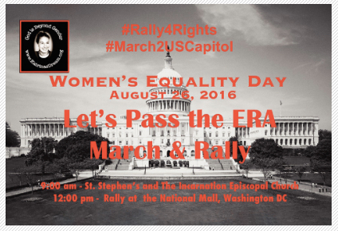
PRESS RELEASE
What: 2nd Annual Women’s Equality Day Vigil, Walk & Rally
Why: Promote the Passage of the Equal Rights Amendment
When: 8:00 am – 5:00 pm Friday, August 26, 2015
Where: St. Stephen and the Incarnation 1525 Newton Street, Washington DC,
to the Upper Senate Area, National Mall, Washington DC
Contact: Ms. Helene de Boissiere Swanson, Founder/Executive Director – Katrina’s Dream <415-233-2048> mailto:helene@katrinasdream.org
Website: http://www.katrinasdream.org/katrinas-story-2/2nd-annual-women-equality-day-2016-rally/

KATRINAS’S DREAM is holding their 2nd ANNUAL WOMEN’S EQUALITY DAY VIGIL, MARCH and RALLY to the US Capitol on August 26, 2016 to prioritize and promote the Three State Strategy to pass the Equal Rights Amendment. The rally is being held to mobilize all people to pass the Equal Rights Amendment (ERA). The day will start in silence, meditation, and prayer at 8:00 am at St. Stephen’s and the Incarnation. Many will meet following the service at 9:30 am to begin there walk in peaceful contemplation taking the same path that many feminist took on August 26, 2015 and commemorate the first march and rally. Others will join up around 11:30 am the White House and proceed to the US National Mall where the rally will begin at 12:00 noon. The group TeensNTheatre will open the rally with a performance. Following the performance the speakers will talk about the intersectionality of racism and sexism, and systemic issues that the ERA would address. They will share their wisdom and personal experiences on the Racial Gender Pay Gap, women’s health care, violence and the rape culture women live with everyday.

The Equal Rights Amendment
Section 1. Equality of rights under the law shall not be denied or abridged by the United States or by any state on account of sex.
Section 2. The Congress shall have the power to enforce, by appropriate legislation, the provisions of this article.
Section 3. This amendment shall take effect two years after the date of ratification.

The ERA is a US Constitutional Amendment that would empower all women and provide for gender equality. The ERA is the unfinished business of the Civil Rights Movement.

THE SCHEDULE

Time Event Location
8:00 am Blessing St. Stephens and The Incarnation -Washington, DC
9:30 am Walk Route
11:30 am White House Meet-up
12:00 pm Rally Upper Senate Park, National Mall, Washington, DC
3:00 pm Meeting Meet with US Senators and US Representatives of the Judicial Affairs Committee

BACKGROUND

Helene Swanson, an aspirant for the priesthood, co-founded Katrina’s Dream in memory of her late mother-in-law, the Rev. Katrina Martha Van Alstyne Welles Swanson. Katrina was one of the 11 women irregularly ordained to the priesthood in 1974, becoming the U.S. Episcopal Church’s first female priests. When the ERA failed to be ratified by the necessary 38 states, Katrina began to recite the Pledge of Allegiance “with Liberty and Justice for SOME!” When questioned “Why ‘some”? she would reply, “Because the ERA was voted down, retired women are more likely to live in poverty than men.”

On March 8, 2014, Helene Swanson left from Golden Gate Bridge, San Francisco, California to make a spiritual pilgrimage to promote the passage of the Equal Rights Amendments. Swanson covered over 7,000 miles (10,000 kilometers) as she made her way traveling through the 15 states that have yet to ratify the ERA. Often Helene slept roadside, at supporters and stranger’s homes alike, and places of worship.

Along the way she met with US Senators and Representative recruiting women’s rights on the national and state level to participate in urging them to co-sponsor the “Three State Strategy” resolutions that US Representative Jackie Speier and US Senator Ben Cardin as lead sponsors have been working on in our US Congress.

On August 26, 2015, a number of feminist joined Swanson on her last four miles to the US Capitol and rallied for the Equal Rights Amendment. That herstoric day and rally has morphed into an annual event. (http://www.katrinasdream.org/katrinas-story-2/pass-the-equal-rights-amendment/dc-era-blessing-walk-and-rally/)

Katrina’s Dream is active in working with the homeless, developing sustainable practices, prison law reform, education in Botswana, developing programs in India, and the full inclusion of women in all areas of life.

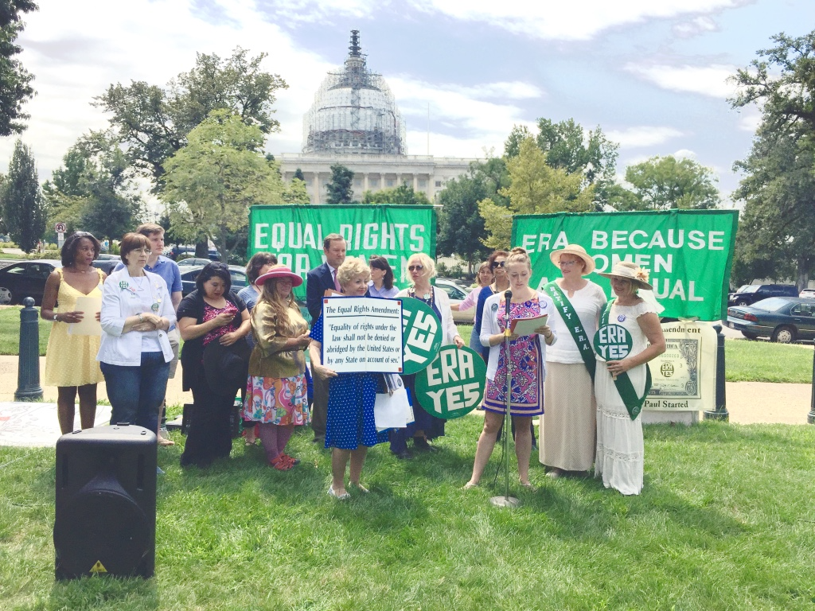

WASHINGTON DC August 26, 2015 - Molly Fishman Molly Fishman from US Representative Jackie Speier reads a statement commending Helene de Boissiere-Swanson on her work to promoting the passage of the Equal Rights Amendment at the March and Rally 2 the US Capitol. Back row: Taylar Nuevelle, Charles Clymer, Karen Teagarden, Bill Van Horn, Deirdre Menard, Dr. E. Faye Williams. Second row: Jocelyn Wang, Helene de Boissiere-Swanson, Eileen Davis, Betty Folliard. Front row: Sandy Oestreich. Photo Credit: Longfei Zhang

