A Liturgy in the Thanksgiving
for the
Ordination of Women
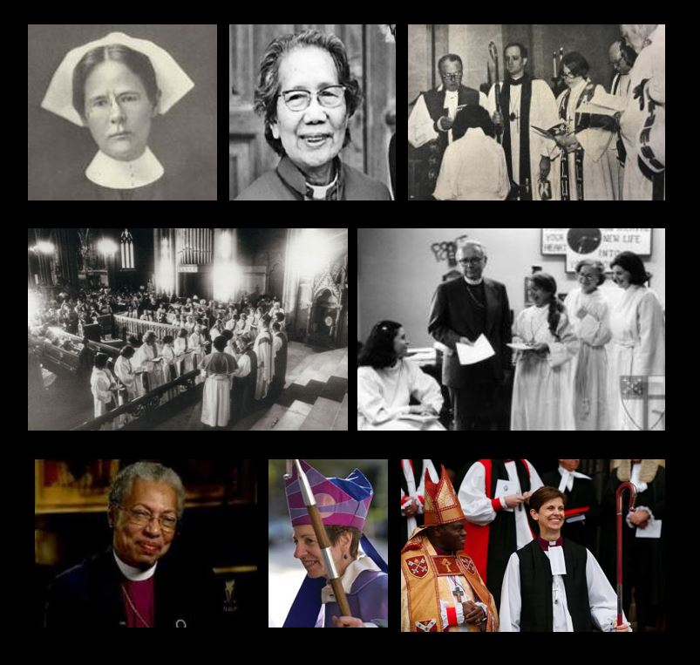

August 26, 2018
A Liturgy in the Thanksgiving for the
Ordination of Women
August 26, 2018

The Holy Eucharist

Processional Hymn | When morning gilds the skies | The Hymnal 1982 427

1 | When morning gilds the skies,
 | my heart, awaking, cries,
 | may Jesus Christ be praised!
 | When evening shadows fall,
 | this rings my curfew call,
 | may Jesus Christ be praised!
2 | When mirth for music longs,
 | this is my song of songs:
 | may Jesus Christ be praised!
 | God's holy house of prayer
 | hath none that can compare
 | with: Jesus Christ be praised!
3 | No lovelier antiphon
 | in all high heaven is known
 | than, Jesus Christ be praised!
 | There to the eternal Word
 | the eternal psalm is heard:
 | may Jesus Christ be praised!
4 | Ye nations of mankind,
 | in this your concord find:
 | may Jesus Christ be praised!
 | Let all the earth around
 | ring joyous with the sound:
 | may Jesus Christ be praised!
5 | Sing, suns and stars of space,
 | sing, ye that see his face,
 | sing, Jesus Christ be praised!
 | God's whole creation o'er,
 | both now and evermore
 | shall Jesus Christ be praised!

Gathering of God's People

The people stand as they are able.

Celebrant: Blessed God: Father, Son, and Holy Spirit
People And blessed be God’s realm, now and for ever.
Amen.

All standing,
Celebrant Holy God,
Holy and Mighty,
Holy Immortal One,
People Have mercy upon us.\

The Collect of the Day

The celebrant says to the people
God be with you.
People And also with you.

Let us pray.
Grant to us, O Creator, we pray, the spirit to think and do always those things that are right, that we, who cannot exist without you, may by you be enabled to live according to your will; through Jesus Christ your Child, who lives and reigns with you and the Holy Spirit, one God for ever and ever. Amen

A period of silence is kept.
The Word of God
First Reading
A reading from the Book of Genesis | Genesis 15- 1-6

¹ After this, Abram had a vision and heard the Lord say to him, “Do not be afraid, Abram. I will shield you from danger and give you a great reward.”
² But Abram answered, “Sovereign Lord, what good will your reward do me, since I have no children? My only heir is Eliezer of Damascus.^{[a]3} You have given me no children, and one of my slaves will inherit my property.”
⁴ Then he heard the Lord speaking to him again: “This slave Eliezer will not inherit your property; your own son will be your heir.” ⁵ The Lordtook him outside and said, “Look at the sky and try to count the stars; you will have as many descendants as that.”
⁶ Abram put his trust in the Lord, and because of this the Lord was pleased with him and accepted him.
Reader The Word of the Lord.
People Thanks be to God.

Psalm 33: 12-15, 18-22 (Read responsively by half verse.)

12 Blessed is the nation whose God is the Lord,
the people he chose for his inheritance.
13 From heaven the Lord looks down
and sees all mankind;
14 from his dwelling place he watches
all who live on earth—
15 he who forms the hearts of all,
who considers everything they do.
18 But the eyes of the Lord are on those who fear him,
on those whose hope is in his unfailing love,
19 to deliver them from death
and keep them alive in famine.

20 We wait in hope for the Lord;
he is our help and our shield.
21 In him our hearts rejoice,
for we trust in his holy name.
22 May your unfailing love be with us, Lord,
even as we put our hope in you.

Glory to the Father and to the Son and to the Holy Spirit; as it was in the beginning is now and will be forever. Amen.
Second Reading
A reading from Hebrews | Hebrews 11: 1-16

¹ To have faith is to be sure of the things we hope for, to be certain of the things we cannot see. ² It was by their faith that people of ancient times won God's approval.
³ It is by faith that we understand that the universe was created by God's word, so that what can be seen was made out of what cannot be seen.
⁴ It was faith that made Abel offer to God a better sacrifice than Cain's. Through his faith he won God's approval as a righteous man, because God himself approved of his gifts. By means of his faith Abel still speaks, even though he is dead.
⁵ It was faith that kept Enoch from dying. Instead, he was taken up to God, and nobody could find him, because God had taken him up. The scripture says that before Enoch was taken up, he had pleased God. ⁶ No one can please God without faith, for whoever comes to God must have faith that God exists and rewards those who seek him.
⁷ It was faith that made Noah hear God's warnings about things in the future that he could not see. He obeyed God and built a boat in which he and his family were saved. As a result, the world was condemned, and Noah received from God the righteousness that comes by faith.
⁸ It was faith that made Abraham obey when God called him to go out to a country which God had promised to give him. He left his own country without knowing where he was going. ⁹ By faith he lived as a foreigner in the country that God had promised him. He lived in tents, as did Isaac and Jacob, who received the same promise from God. ¹⁰ For Abraham was waiting for the city which God has designed and built, the city with permanent foundations.
¹¹ It was faith that made Abraham able to become a father, even though he was too old and Sarah herself could not have children. He^{[a]} trusted God to keep his promise. ¹² Though Abraham was practically dead, from this one man came as many descendants as there are stars in the sky, as many as the numberless grains of sand on the seashore.
¹³ It was in faith that all these persons died. They did not receive the things God had promised, but from a long way off they saw them and welcomed them, and admitted openly that they were foreigners and refugees on earth. ¹⁴ Those who say such things make it clear that they are looking for a country of their own. ¹⁵ They did not keep thinking about the country they had left; if they had, they would have had the chance to return. ¹⁶ Instead, it was a better country they longed for, the heavenly country. And so God is not ashamed for them to call him their God, because he has prepared a city for them.

Reader The Word of the Lord.
People Thanks be to God.
The people stand as they are able.

Gradual Hymn | Creator of the Stars | The Hymnal 1982 60, verses 1 & 2

1 | Creator of the stars of night,
 | your people's everlasting light,
 | O Christ, Redeemer of us all,
 | we pray you hear us when we call.
2 | In sorrow that the ancient curse
 | should doom to death a universe,
 | you came, O Savior, to set free
 | your own in glorious liberty.

Gospel
The Holy Gospel of our Lord Jesus Christ according to Luke Luke 1:46-55
Glory to you, Lord Christ

⁴⁶ Mary said,
“My heart praises the Lord;
⁴⁷ my soul is glad because of God my Savior,
⁴⁸ for he has remembered me, his lowly servant!
From now on all people will call me happy,
⁴⁹ because of the great things the Mighty God has done for me.
His name is holy;
⁵⁰ from one generation to another
he shows mercy to those who honor him.
⁵¹ He has stretched out his mighty arm
and scattered the proud with all their plans.
⁵² He has brought down mighty kings from their thrones,
and lifted up the lowly.
⁵³ He has filled the hungry with good things,
and sent the rich away with empty hands.
⁵⁴ He has kept the promise he made to our ancestors,
and has come to the help of his servant Israel.
⁵⁵ He has remembered to show mercy to Abraham
and to all his descendants forever!”

Priest The Gospel of Christ
People Praise to you. O Christ

Gradual Hymn | Creator of the Stars | The Hymnal 1982 60, verse 6
6 | To God the Father, God the Son,
 | and God the Spirit, Three in One,
 | praise, honor, might, and glory be
 | from age to age eternally.

Sermon
The people stand as they are able.
The Nicene Creed

We believe in one God,
the Father, the Almighty,
maker of heaven and earth,
of all that is, seen and unseen.
We believe in one Lord, Jesus Christ,
the only Son of God,
eternally begotten of the Father,
God from God, Light from Light,
true God from true God,
begotten, not made,
of one Being with the Father.
Through him all things were made.
For us and for our salvation
he came down from heaven:
by the power of the Holy Spirit
he became incarnate from the Virgin Mary,
and was made man.
For our sake he was crucified under Pontius Pilate;
he suffered death and was buried.
On the third day he rose again
in accordance with the Scriptures;
he ascended into heaven
and is seated at the right hand of the Father.
He will come again in glory to judge the living and the dead,
and his kingdom will have no end.
We believe in the Holy Spirit, the Lord, the giver of life,
who proceeds from the Father and the Son.
With the Father and the Son he is worshiped and glorified.
He has spoken through the Prophets.
We believe in one holy catholic and apostolic Church.
We acknowledge one baptism for the forgiveness of sins.
We look for the resurrection of the dead,
and the life of the world to come. Amen.

Prayers of the People, A Litany of Thanksgiving for the Ordination of Women

The bolded lines are spoken by the People

Litanist
Let us give thanks to God, who has created us and is transforming us and the Church.

For the gifts of ministry and leadership which you have bestowed through Baptism upon women and men,
Our souls proclaim the greatness of God,
Our spirits rejoice in God our Savior.

For the ministries of ordained women – bishops, priests, and deacons – who serve and lead in your Church,
Our souls proclaim the greatness of God,
Our spirits rejoice in God our Savior.

For Florence Li Tim-Oi, ordained priest in Hong Kong in 1944, and for the three other women ordained priests in China in 1971 and 1973,
Our souls proclaim the greatness of God,
Our spirits rejoice in God our Savior.

For the women ordained priest in Philadelphia in 1974; Merrill Bittner, Alla Bozarth--Campbell, Allison Cheek, Emily Hewitt, Carter Heyward, Suzanne Hiatt, Marie Moorefield, Jeannette Piccard, Betty bone Schiess, Katrina Welles Swanson, and Nancy Hatch Wittig; and for those ordained in Washington D.C. in 1975; Diane Tickel, Alison Palmer, Betty Powell and Lee Mc Gee.
Our souls proclaim the greatness of God,
Our spirits rejoice in God our Savior.

For the courageous leadership of those who envisioned the possibilities of a priest hood that includes women as well as men,
Our souls proclaim the greatness of God,
Our spirits rejoice in God our Savior.

For the faithfulness and persistent vision of those in diocese and denominations where women cannot be ordained, who long to experience the ordained leadershsip of women as well as men,
Our souls proclaim the greatness of God,
Our spirits rejoice in God our Savio.r

For our children who are growing up with an image of ordained leadership which includes both women and men,
Our souls proclaim the greatness of God,
Our spirits rejoice in God our Savior.

For ordained women who have died and joined the communion fo All your Saints
Our souls proclaim the greatness of God,
Our spirits rejoice in God our Savior.

Confession of Sin
If we say that we have no sin, we deceive ourselves, and the truth is not in us. But if we confess our sins, God, who is faithful and just, will forgive our sins and cleanse us from all unrighteousness. 1 John 1:8,9
Let us confess our sins against God and our neighbor.
The people kneel as they are able.
A period of silence is kept.

Most merciful God,
we confess that we have sinned against you
in thought, word, and deed,
by what we have done,
and by what we have left undone.
We have not loved you with our whole heart;
we have not loved our neighbors as ourselves.
We are truly sorry and we humbly repent.
For the sake of your Son Jesus Christ,
have mercy on us and forgive us;
that we may delight in your will,
and walk in your ways,
to the glory of your Name. Amen.

Absolution

The celebrant stands and says
Almighty God have mercy on you, forgive you all your sins through our Lord Jesus Christ, strengthen you in all goodness, and by the power of the Holy Spirit keep you in eternal life. Amen.
The Peace

All stand as are able
Celebrant | The peace of the Lord be always with you.
People | And also with you.
The Holy Communion
The Priest says
Offer to God a sacrifice of thanksgiving, and make good your vows to the Most High. Psalm 50:14

Offertory Anthem

Representatives of the congregation bring the people’s offerings of bread and wine, and money or other gifts, to the deacon or celebrant.
The people stand while the offerings are presented and placed on the Altar.

The Great Thanksgiving
Priest The Lord be with you.
People And also with you.
Priest Lift up your hearts.
People We lift them to the Lord.
Priest Let us give thanks to the lord our God.
People It is right to give him thanks and praise.

It is right, and a good and joyful thing, always and everywhere to give thanks to you, God Almighty, Creator of heaven and earth. For in the multitude of your saints you have surrounded us with a great cloud of witnesses that we might rejoice in their company, and run with endurance the race that is set before us; and, together with them, receive the crown of glory that never fades away.

Therefore we praise you, joining our voices with Angels and Archangels and with all the company of heaven, who for ever sing this hymn to proclaim the glory of your Name:
The Hymnal 1982, Service Music #114
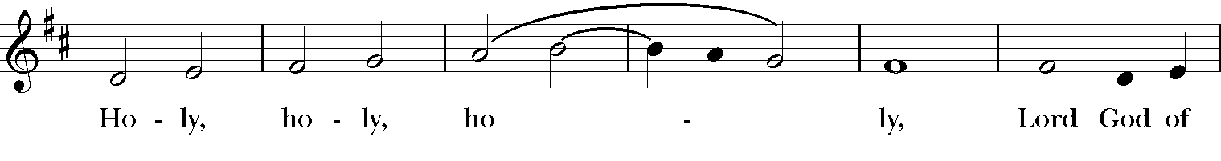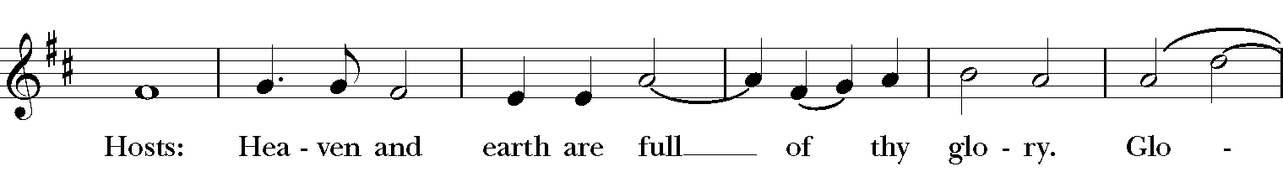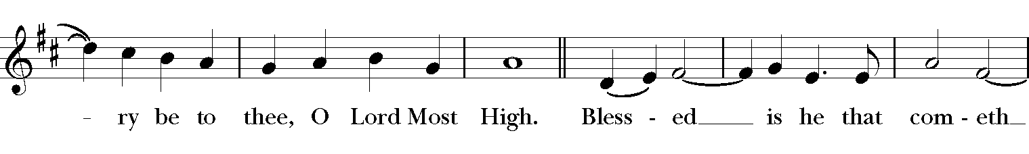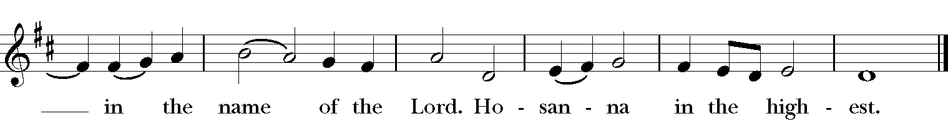

The people stand or kneel as are able
Then the Celebrant continues

Holy and gracious Father: In your infinite love you made us for yourself; and, when we had fallen into sin and become subject to evil and death, you, in your mercy, sent Jesus Christ, your only and eternal Child to share our human nature, to live and die as one of us, to reconcile us to you, the God and Creator of all.

Christ stretched out his arms upon the cross, and offered himself in obedience to your will, a perfect sacrifice for the whole world.

On the night he was handed over to suffering and death, our Lord Jesus Christ took bread; and when he had given thanks to you, he broke it, and gave it to his disciples, and said,

“Take, eat: This is my Body, which is given for you. Do this for the remembrance of me.”

After supper he took the cup of wine; and when he had given thanks, he gave it to them, and said,

“Drink this, all of you: This is my Blood of the new Covenant, which is shed for you and for many for the forgiveness of sins. Whenever you drink it, do this for the remembrance of me.”

Therefore we proclaim the mystery of faith:
Celebrant and people
Christ has died.
Christ is risen.
Christ will come again.
We celebrate the memorial of our redemption, O God, in this sacrifice of praise and thanksgiving. Recalling Christ’s death, resurrection, and ascension, we offer you these gifts.

Sanctify them by your Holy Spirit to be for your people the Body and Blood of your Child, the holy food and drink of new and unending life in Christ. Sanctify us also that we may faithfully receive this holy Sacrament, and serve you in unity, constancy, and peace; and at the last day bring us with all your saints into the joy of your eternal realm.

All this we ask through Jesus Christ. By whom, and with whom, and in whom, in the unity of the Holy Spirit all honor and glory is yours, Almighty God, now and for ever. Amen
The Lord’s Prayer

As our Savior Christ has taught us, we now pray

Our Father, who art in heaven,
hallowed be thy Name,
thy kingdom come,
thy will be done,
on earth as it is in heaven.
Give us this day our daily bread.
And forgive us our trespasses,
as we forgive those who trespass against us.
And lead us not into temptation,
but deliver us from evil.
For thine is the kingdom, and the power, and the glory,
for ever and ever. Amen.

The Breaking of the Bread
The Celebrant breaks the consecrated Bread.
A period of silence is kept.
Priest Christ our Passover is sacrificed for us;
People Therefore let us keep the feast.
The Gifts of God for the People of God.

The ministers receive the Sacrament in both kinds, and then immediately deliver it to the people with these words
The Body of Christ, the bread of heaven.
The Blood of Christ, the cup of salvation.

The people stand as they are able.

Communion Hymn | Thou, who at thy first Eucharist didst pray | The Hymnal 1982 315

1 | Thou, who at thy first Eucharist didst pray
 | that all thy Church might be for ever one,
 | grant us at every Eucharist to say
 | with longing heart and soul, "Thy will be done."
 | O may we all one bread, one body be,
 | through this blest sacrament of unity.
2 | For all thy Church, O Lord, we intercede;
 | make thou our sad divisions soon to cease;
 | draw us the nearer each to each, we plead,
 | by drawing all to thee, O Prince of Peace;
 | thus may we all one bread, one body be,
 | through this blest sacrament of unity.
3 | So, Lord, at length when sacraments shall cease,
 | may we be one with all thy Church above,
 | one with thy saints in one unbroken peace,
 | one with thy saints in one unbounded love;
 | more blessèd still, in peace and love to be
 | one with the Trinity in Unity.

Postcommunion Prayer

After the Communion the Celebrant says
Let us pray.

Celebrant and People
Eternal God, heavenly One,
you have graciously accepted us as living members
of your Child our Savior Jesus Christ,
and you have fed us with spiritual food
in the Sacrament of Christ’s Body and Blood.
Send us now into the world in peace,
and grant us strength and courage
to love and serve you
with gladness and singleness of heart;
through Christ our Lord. Amen.
Blessing

The Priest may bless the people
You have eaten the food that endures for eternal life, Christ, the true bread from heaven; be filled with love.

With all humility, gentleness and patience, maintain the unity of the Spirit in the bond of peace.

And the blessing of our bounteous God, Father, Son and Holy Spirit, be with you and dwell within you, now and for ever. Amen.

Recessional Hymn | O God, our help in ages past | The Hymnal 1982 680

1 | O God, our help in ages past,
 | our hope for years to come,
 | our shelter from the stormy blast,
 | and our eternal home:
2 | under the shadow of thy throne
 | thy saints have dwelt secure;
 | sufficient is thine arm alone,
 | and our defense is sure.
3 | Before the hills in order stood,
 | or earth received her frame,
 | from everlasting thou art God,
 | to endless years the same.
4 | A thousand ages in thy sight
 | are like an evening gone;
 | short as the watch that ends the night
 | before the rising sun.
5 | Time, like an ever-rolling stream,
 | bears all our years away;
 | they fly, forgotten, as a dream
 | dies at the opening day.
6 | O God, our help in ages past,
 | our hope for years to come,
 | be thou our guide while life shall last,
 | and our eternal home.

Dismissal

Deacon | Let us go forth into the world,  Rejoicing in the power of the Spirit. Alleluia, alleluia.
People | Thanks be to God. Alleluia, alleluia.

Created using riteworship. All musical selections reprinted with the permission of ritesong. All rights reserved. Used with permission.

Notes by Katrina and George

In early August of 2004 Katrina mentioned to her sister priest, Merrill Bittner that Jonathan Appleyard, rector of St. Savior’s, Bar Harbor, Maine, had invited her to celebrate and preach in recognition of the 30th Anniversary of the ordination to the Prieshood on July 29, 1974 at the Church of the Advocate in Philadelphia, Pennsylvania. She happily acquiesced to Merrill’s request for a copy of the inclusive language service (including both women and men) edited by Katrina and Jonathan. However, after the service Katrina realized that there were some exclusive language portions that needed translation. As some of you know, Katrina’s been squawking about inclusive language for a very long time.

“How I wish my ears had never been opened.” George and Katrina hope this liturgy will work for the remaining 15 irregulars and other folks who have shared the inclusive language journey with us.

The booklet is designed to contain everything needed for the service of Holy Communion in one continuas format. The revision tries, in a respectful, non-heretical and accurate manner to include all people as we worship together. This work on inclusive language has no intention of disrespecting our sisters and brothers who have felt respected and valued throughout their lives while working in the real world among men.

Personally, for pastoral reason while using very familiar prayers, Katrina sometime says the exclusive “Father, Son & holy Sprit.” For us inclusion of all people rather than balance or “getting even” is desirable and fair. Our hope is to include 100 % rather than 49% or 51% of people praising God, the Holy Trinity.

Rite II and Canon ! seem to be the most popular of the various option in the Book of Common Prayer 1979. That is the one we have chosen, keep it as simple as possible when there are options. We selected propers that could be used during any season. So there would be a “constant” or “least change as possible” for familiarity sake: the propers of the Holy Trinity seem appropriate. This service therefore uses propers #1 of the Holy Trinity (Various Occasions BCP p251 and 927) and offers an alternative on page 7 (written by George Gaines Swanson) to the pregace for Trinity Sunday, p380.

Wherever Biblical Passages have been used they are based on the Good News Bible – Today’s English Version. We appreciate the spirit of this version and its mission to spread God’s good news as fully as possible to include all people everywhere, “and to Christ be the glory forever and ever!”

We decided to use hymns whose language already included all people.

Note by George Gaines Swanson, August 6, 2008:
I believe the liturgy above was prepared and used by Katrina when she celebrated at St. Saviour’s on August 8, 2004. Her final celebration before her death may have been a few eweeks later at St. John’s in South West Harbor,Maine using this same liturgy.
Note by Helene de Boissiere - Swanson August 6, 2018
At the 2018 Triennial of The Prostestant Episcopal Church of the United States of America, Katrina’s Dream handed out hundreds of copies of the Liturgy in Thanksgiving of the Ordination of Women Priest. Many of the attendees agreed to hold this service across the United States and to include in their petitions that the United States of America include the Equal Rights Amendment in their petitions and prayers to God to move the U.S.A. to include women in their U.S. Constitution.
A Katrina’s Dream Publication Email: helene@katrinasdream.org
P.O. Box 32003 Telephone: (415) 233-2048
Washington, D.C. 20007

